1. 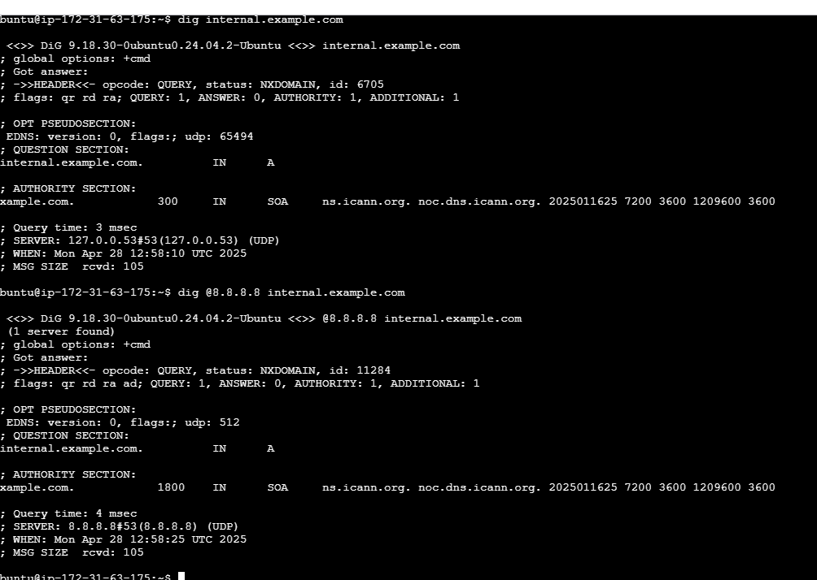**Verify DNS Resolutio**
2. **Hhtt**



**In both cases**, the result says NXDOMAIN, which means **the domain does not exist**.

**2. Diagnose Service Reachability:**



**f**

**the web service is reachable on port 80.  
Port 443 is not listening, so HTTPS is not reachable.**

**3- List All Possible Causes**

**DNS layer**  
 Domain internal.example.com is not registered  
 No DNS record for internal.example.com

**Network layer**  
 Firewall is blocking the connection  
 Wrong routing, traffic not reaching the server

**Service layer**  
 Web server is only listening on localhost Service is down or has a wrong setup

**4- Propose and Apply Fixes**

**DNS layer**

**Problem**: Domain internal.example.com is not registered

**Fix**: Register the domain or create a DNS record with your DNS provider

**Problem**: No DNS record for internal.example.com

**Fix**: Add an A record pointing to the server IP in your DNS provider panel

**Network layer**

**Problem**: Firewall is blocking the connection  
**Fix**: Allow HTTP and HTTPS with

sudo ufw allow 80

sudo ufw allow 443

sudo ufw reload

Problem: Wrong routing, traffic not reaching the server  
Fix: Correct server's network settings or fix routes in network configuration

**Service layer**

**Problem:** Service is down or has wrong setup  
**Fix:** Start or fix service

sudo systemctl start apache2

sudo systemctl enable apache2

**Problem**: Web server only listening on localhost  
**Fix**: Update web server config (like Apache Listen 0.0.0.0:80) and restart service

sudo systemctl restart apache2